Meadow Creek Waterways Rehabilitation Project
Frequently Asked Questions

Thank you for reviewing the project documents provided. As you know, the planning for waterways restoration takes significant time and money. Each homeowner will be asked to participate in the decision-making process. What follows are the questions the board has received from homeowners to date. Please review the questions and answers. You may still have a lot of questions – which is good. Please send your questions to kendrafiscelli@gmail.com

Q1: What are the most important goals of the Rehabilitation Project (“Project”), and how will they be measured?
A1: Restoring water depths to original 1992 depths by removing an estimated 12,700 cubic yards of sludge is the primary goal. Although the Committee does not know with precision the original depths of the ponds, dredging is generally conducted until solid (rock/cobble) strata are encountered. This was the case during the November 2022 muck-out of the small pond area near the Pond #4 pumphouse. Secondary goals include bank and island stabilization to prevent future erosion, pruning and removal of trees to reduce/eliminate deposition of organic matter into the ponds, and restoration/replacement of the footbridges and HOA irrigation system where warranted. The general approach is to “get in and get out” of the environmentally sensitive pond areas to minimize disturbance to flora, fauna and the pond banks, and to revegetate/replant one-time instead of multiple times.
Q2: Why is there so much less sludge to be removed from Pond #4, compared to the other ponds?
A2: Depth and water quality. Pond #4 is the largest, and deepest pond and is fed exclusively from groundwater upwelling and supplemental groundwater pumping with our single water well. The absence of “ditch water” as a supply source to Pond #4, which water may include high and varying levels of Nitrogen and Phosphate nutrients, may be instrumental in less algae and weed growth in Pond #4, resulting in less sludge deposition. Water sampling and testing will bear this out.
Q3: How did our waterways look back in the early-1990’s compared to now?

A3: Except for an undated aerial photograph, the Waterways Committee (“Committee”) could not readily locate any photographs or other documentation as to the character and condition of the Meadow Creek (“MC”) waterways during the 1990’s. The Committee requests that any Owners who have historical photos provide copies to DS Property Management such that the Committee and Board can use them as a touchstone for refining the scope of the Project.

What the Committee does know is that, in 2007, the deposition of sediment and organic matter (i.e., “sludge”) in the waterways became a concern for the HOA and a professional engineering assessment was conducted. See July 26, 2007 Estimate by SPF Engineering (Appendix J). At that time, SPF estimated a quantity of 1,150 cubic yards of sludge needed to be removed from select aeras in the MC ponds. Fast-forward to 2022, and the quantity of sludge to be removed increased 10-fold, to 12,700 cubic yards. See June 2022 Estimate by SPF Engineering. The 10-fold increase in estimated sludge volume implies that the volume of sludge deposition over the 15 years from 2007 to 2022 was an order of magnitude greater than the deposition during the first 15 years (1992-2006). This is quite likely due to the maturation of the HOA tree canopy with its attendant non-linear increase in organic matter deposition (i.e., leaves and branches) into the ponds.

Q4: What is the timeline for getting all this work done? Will a phased approach be used?

A4:
  - Phase 1: Pilot Project - Winter 2023: Initially, a specific area west of N. Lake Shore Dr up to the foot bridge will be targeted for proof-of-concept. Here, the same scope of work will be performed as planned for the larger ponds, but on a much smaller scale. This includes dredging, tree pruning/removal, bank enforcement and re-vegetation and bridge repair or replacement. The method of dredging to be used for the Pilot Project area will be to first de-water and then mechanically excavate. The objective is to provide a realistic, sample-size of the work and costs involved that can serve as a basis for refining the scope and costs of Phases 2 & 3. Timing for the Pilot is expected to take 1-2 months.
  - Phase 2: Remainder of Pond 2 plus Pond3 – Winter 2024: Ponds 2 & 3 run east and west of N lakeshore Drive. The method of dredging this area will be the same as for the Pilot Project. The timing to completion could take up to three months.
  - Phase 3: Ponds 1, 4, & 5 – Winter 2025: Pond 4 is the 2-acre pond North of the clubhouse. Ponds 1 and 5 are located on the west side of the HOA, separating MC from Silver Wood HOA. The costs for Ponds 1 & 5 would be shared with Silverwood, as those ponds are within the Silverwood HOA boundary, but impact the outflows from MC Ponds 2, 3, and 4. The method of dredging these areas will likely be a combination of de-watering and mechanical excavation, and the use of a portable suction dredge (hydraulic dredging). Timing to completion could take up to three months.

Q5: Why was Pond #2 selected for the Pilot?
A5: Pond #2 was selected for the Pilot (Phase 1 of the project) because it is readily accessible to three public roads (Lakeshore, Blackbird, Cattail), providing a multiplicity of sites for material removal and staging. It also minimizes the impact on adjacent Owners (6) and traffic flows, and keeps estimated Pilot costs to approximately 10-20% of total estimated Project costs. The existing Pond #2 footbridge has integrity and can remain in place during the Pilot. The Pond #3 footbridge is in poor condition, and provides the primary access/egress for material removal from Pond #3, impacting many more Owners (26). In addition, Pond #3 has two large islands with numerous dead/dying trees, which would significantly increase the Pilot cost for tree pruning/removal and island stabilization/restoration. The primary objectives of the Pilot are to prove up estimated unit costs versus actual (e.g., $/cubic yard of sludge removed and disposed), and to assess the effectiveness of dewatering and mechanical dredging. As such, Ponds #1, #4 and #5 are not good candidates for the Pilot because they will require hydraulic dredging, and Pond #3 would be more disruptive and costly than the proposed Pond #2 Pilot area.

Q6: Where specifically will the Pond #2 Pilot dredging project take place?
A6: Pond #2, from Lakeshore Drive to the footbridge that connects Blackbird Way with N. Cattail Way.

Q7: Will the HOA membership need to vote on the Pilot? On the other proposed phases of the project?
A7: Yes. The MC HOA CC&R’s require a majority vote of the membership to impose Special Assessments, which are defined as assessments in excess of 20% of the then-current budgeted gross annual HOA expenses, which are $327,290.56 for 2023. The cost of the Pilot project and each subsequent phase of the project each exceed $65,000 (20% of $327K). The Committee’s recommendation is that one HOA membership vote be taken for the entire 3-phase project, to ensure project delivers the anticipated benefits in the timely and most cost-effective manner. The cost estimates for Phases 2 & 3 would need to be refreshed after completion of the Pilot. Breaking the Project into three phases allows for spreading of the cost assessments to HOA members across a 3-year period. Upfront approval of all three phases is necessary to avoid the necessity of having to hold a membership vote on each phase. It also avoids the potential for member holdout situations on Phases 2 & 3, which would undermine the collective benefits of HOA investments made in the prior phases.

Q8.How did the MC Waterways Transformation (now, “Rehabilitation”) team get formed and what are some of the essential tasks involved?

A8:
- The MC Waterways Rehabilitation team members are volunteers from within the Meadow Creek HOA. The team was tasked with coordinating the work for rehabilitating the HOA waterways and adjacent embankments, improving year-round waterflows and ensuring that our HOA owned trees and bridges have integrity to last another 50 years with appropriate ongoing maintenance.
- Each team member expressed interest in the Project and a willingness to contribute skills needed to oversee and complete one or more tasks within the project scope of work. Project tasks include things like Water and Sludge Sampling and Analysis, Waterway Dredging and Disposal, Tree Inventory and Health/risk assessment, new Water Wells (deferred), Walkway Bridges and Bank Revegetation. (See MC Waterways Transformation Team Charter document).

Q9: Will additional water wells be drilled as part of the Project?
A9: No. The drilling of additional wells is not included within the current Project scope and budget due to regulatory and cost uncertainties. If the Board requests that the Committee assess the feasibility of drilling new wells, the Committee will develop its assessment as a standalone project.
Q10: How do we know that the HOA owns all of the pond banks abutting Pond #4?
A10: The HOA’s attorney has made that determination based upon the original subdivision Plat Maps and the Ada County Assessor property records. The property boundary surveying work proposed for each phase of the Project will locate the property corners for all properties abutting all of the ponds, to ensure the HOA does not errantly disturb or remove trees, islands, etc. that reside on Owner Lots. Identifying the property corners/lines will also guide any repair and remediation by the HOA of any damage caused by Project activities.
Q11: On the Transformational Team, why is Neal listed in the row with “Silverwood HOA”? Is he coordinating with that HOA?
A11: Neal Timmerman, President of MC HOA, is listed as the main point of contact with Silverwood HOA and will represent the MC Board for making any decisions taken by the MC Board regarding project scope and costs for Ponds 1 & 5. The Committee works closely with Silverwood and EcoLake to maintain our shared waterways and communicates frequently with the MC Board, and has had a reciprocity and cost-sharing agreement in place between the two HOAs for some years now.

Dredging – Many of the following questions were follow-up to Golden-Enviro’s dredging proposal dated May 31, 2022.

- Upstream Water Quality and Flow: Our water rights are limited. For the Phase-1 ponds 2 & 3, we receive approximately 5 cubic feet per second (2,250 gpm) from several upstream irrigation sources. For ponds 4a & 4b, we rely upon natural groundwater and aquifer flow, supplemented by 0.04 cfps (~18 gpm) ground water produced from MC’s groundwater well. We have no control over the quality of the water (e.g., Nitrogen and Phosphate loading) or the actual flow rate, both now and, in the future.

Question 1a: What measures could we take (or, refrain from taking) to enhance the current state of our waterways, yet ensure long-term sustainability and least-cost operation in the event our water supply volumes and/or quality are compromised in future? I.e., would we regret having spent significant funds dredging, only to find our water supplies cut in half 2 years from now?
The single most effective action we can take as an HOA is to keep organic matter (i.e., leaves, branches) and fertilizer runoff (Nitrogen and Phosphates) from being deposited into our waterways. This action, aimed at water quality, pays long-term dividends irrespective of the annual water allocations and flows. Preventing organic matter deposition results in deeper ponds with cooler water temperatures, and less algae and weed growth. Routine Water and Sediment sampling and analysis could be performed to ensure nutrients (Nitrogen and phosphates) are managed at optimal levels. Aerators work great, and are better than waterfalls. We have six aerators.
  - Question 1b: What is your opinion of the economic and regulatory feasibility of permitting and drilling a new well to provide a minimum of 200 gpm of groundwater flow, year-round, to Ponds 4a and 4b?
This is a possible option but can be costly from both a capital and operating perspective (electricity, pump maintenance). That said, increased water flows would help reduce the buildup of organic matter and nutrients, thereby significantly improving and maintaining water quality. From a regulatory standpoint, it is getting more difficult each year to permit new water wells. Any permits granted would restrict water use to aesthetics only; no use for irrigation of any kind. This should not be a problem, as the HOA currently irrigates with purchased Garden City water. And, with the water table being so shallow in our HOA, permitting new wells may be feasible provided withdrawal rates are modest. The Department of Water Resources and a drilling contractor would be consulted for a least-cost/best-fit solution that balances permitting feasibility with capital and operating costs and water quality benefits. The HOA should also consider new wells for the other ponds as well as Ponds 4a and 4b.

- Bank Stabilization and Slump Prevention: While we want to remove the accumulated sediment and decaying organic matter from our waterways, we also are cognizant that slope stabilization may be required to arrest any natural or man-made erosion or slumping which will result in having to re-dredge again in the future. The objective is to maintain the integrity and sustainability of our waterways and the adjacent property-owner property. Several residents located adjacent to our waterways have already implemented self-help in this regard, installing boulders and other anti-erosion remedies.

  - Question 2: Should rip-rap, bouldering or other slope stabilization solutions be employed in tandem with, or immediately after, any dredging work on the ponds? If so, what cost-effective methods has Golden Environmental successfully deployed in the past?
Yes, it would be beneficial to place boulders and/or rip-rap rocking to stabilize the banks where needed while water levels are at a minimum after winter dredging. Rock or boulder placement can be sub-contracted out. It is expensive. We would likely install geotech fabric, then the rock layer. In the past, Golden has used a 4000-horsepower pump and a temporary pipeline to evacuate water during rock placement.
- Re-Use of Dredge Spoil versus Hauling Offsite: We noted that approximately 1/3 of the total cost of the dredging proposal was for hauling and disposing of dredged material.

  - Question 3a: Based on your experience, and assessments of the quantity and compositional characteristics of the material to be dredged, what is the possibility of beneficial reuse of that material within the MC complex for slope stabilization, island enhancement, etc.? One area of consideration to use dredging material is just to the east of the north side footbridge in Pond 3.
Likely limited re-use of dredged material. To contain the dredging material (sludge), a woody or sand additive will most likely be needed because the sludge has a very fine particle structure. If we don’t add the additive, it will set up like hardpan. Suggest talking with pondside owners who have already installed rip-rap rocking to understand what they did with the sludge (if any) that was removed.
  - Question 3b: What is your opinion regarding channel dredging mid-pond, to increase depth and velocity, versus removal of all the sediment up to the banks?
It is recommended by Golden Environmental to not increase depth only at the centers of the ponds. Dredging mid-pond without dredging near the bank will most likely cause the dredged channel to fill back in during the first year or two. It would be more beneficial to dredge completely, from shoreline to mid-pond, for a better long-term cost-benefit.
- Adjacent Tree Removal and Pruning: As you have seen, we have many trees and large shrubs that encroach upon our waterways. Many of these trees are structurally unsound, subject to toppling (or, already in the ponds), at end-of-life, or in need of aggressive pruning to ensure long-term sustainability. Many may be replaced, but with species that are more long-lived and more adapted to riparian environments with widely fluctuating groundwater levels.

  - Question 4a: What is your opinion as to the optimal timing of tree removal/pruning along our waterways, should we proceed with dredging the ponds in accordance with your proposal?
Large tree and stump removal would best be performed just after dredging while the winter water levels are minimal. Pruning would also be best performed in the late-Fall, just prior to dredging, as any fallen debris would be removed during dredging.
  - Question 4b: Does Golden Environmental have equipment to assist in the removal of large fallen limbs or trees or stumps in the waterways that would impede the dredging process?
Golden Environmental has the equipment for removal of large objects. Trees would be best removed during the dredging process. Golden would likely partner with a bonded tree care and removal company, who would perform any tree felling as well as debris chipping and haul-off.
- Bridge Repair/Replacement: Similar to the trees adjacent to our waterways, our main road-bridge and several foot-bridges are in need of repair and potential replacement to ensure long-run safety and aesthetic integrity.

  - Question 5: What is your opinion as to the optimal timing of any road- and/or foot-bridge repair or replacement along our waterways, should we proceed with dredging the ponds in accordance with your proposal?
The HOA would coordinate maintenance of the road bridge separately with Ada County Highway Department. Footbridge repair and/or replacement would be best performed immediately after dredging. It is recommended that we not remove footbridges prior to dredging. Some footbridges have irrigation & electrical attached. A footbridge engineer should be consulted prior to dredging work. Footbridge replacement, with bridge sections being shop-fabricated and then field-placed, would likely be most efficient from a cost and schedule perspective.
- Nitrogen and Phosphate Runoff: Homeowners are well-meaning in their efforts to maintain the health and beauty of their residential landscapes and the riparian areas adjacent to our waterways. Unfortunately, this results in Nitrogen and Phosphate runoff into the waterways that compromises water quality and plant/marine-life balance.

  - Question 6a: What best practices are you aware of in regards to educating residential property owners as to the detrimental impacts of Nitrogen and Phosphate runoff on water quality and the long-term health of waterway flora and fauna?
The best practice would be to hold an annual tree and landscape care seminar for HOA members, coupled with communication via newsletters and bulletins from DS Property Management posted to the HOA homepage. A general rule-of-thumb is to NOT apply any Nitrogen or Phosphorus fertilizers of any kind (even “slow-release”) within 10 feet of any waterway or drainageway. Also, given that our gutter catch basins are piped into our ponds, special attention should be paid to avoiding (and/or, cleaning up) deposition of fertilizers onto our sidewalks, gutters, and streets. Homeowners must communicate the ”don’t fertilize here” and “keep it on the grass and off the sidewalks, gutters and streets” messages to their gardeners and landscape maintenance contractors. The HOA could adopt an annual attestation process wherein each HOA member signs a form annually attesting that they have (and will) held that discussion with their contractors.

  - Question 6b: What testing has/can Golden do to assess the current impacts of Nitrogen and Phosphorus runoff on water quality and sediment deposition in our waterways?
Golden Environmental would subcontract out the testing. Recommend water testing be performed by our current Waterways Management company Eco Lake. Water testing can be done at an affordable rate. Sludge samples may need to be sent to a specialized lab for analysis if Eco Lake does not have the requisite analysis equipment and capabilities.

- Catch Basins vs. Dredging: The alternative of developing catch basins that could be routinely mucked-out versus large-scale dredging of entire waterways was proposed at our September 2022 Committee meeting. The idea was to “use the water we have”, and just recycle it from downstream to upstream to continuously move sediment from upstream to downstream for eventual removal.

  - Question 7: What is your opinion of the efficacy of employing catch basins and recirculating pumps as a long-term alternative to dredging of accumulated material, as applied to the current MC waterway situation (i.e., 25 years of accumulated deposition)?
Catch basins can be deployed and would be beneficial as part of a long-term Waterways Management Plan. A recirculating pump would also prove beneficial where there is minimal water flow such as in ponds 1 and 5, and perhaps also pond 4. Frequency and cost of catch basin muck-out is a big uncertainty. One potential drawback of installing catch basins is that HOA members may falsely believe that doing so will alleviate the need to minimize the deposition of organic matter and Nitrogen/Phosphate nutrients into the ponds. Also, only buoyant organic matter (i.e., most leaves) would likely be deposited in the catch basins. Heavier matter (branches, fertilizer pellets/granules) would likely remain deposited where they land.

Trees
- For the tree replacement and maintenance, will there be an additional assessment, and when will that cost estimate be available?

  - An estimate of costs and timing of tree pruning, removals and replacements will be generated after the HOA tree inventory is reviewed by an International Society of Arboriculture (ISA) Arborist with Tree Risk Assessment Certification. The Arborist would make prioritized recommendations. Any required increase in annual costs for tree care/removal/replacement would likely be included in the HOA’s fiscal year budget, not as a separate assessment.
- What did the Tree Inventory reveal about the health of our current tree stock, and where we can expect to spend money replacing/replanting?

  - See Tree Inventory Summary (excerpts below). Overall, 71% of our HOA-owned trees are in Fair or worse health, while the other 29% are Good, Very Good or Excellent. In other words, 2 out of every 3 HOA-owned trees are surviving, but not thriving. This is due to a multiplicity of factors: 1) Species selection 30 years ago; 2) Lack of supplemental watering during first 1-3 years after planting; 3) Fluctuating/declining water levels in ponds; 4) Invasive pests such as Lilac Ash Borer and Sequoia Pitch Moth.

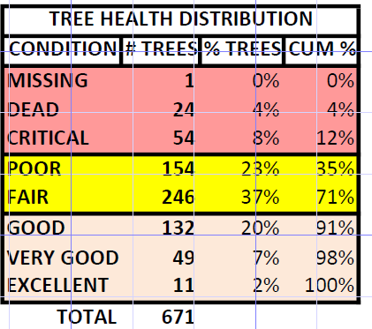

Several tree species (e.g., Amur Maples) are in extremely poor health and/or at end of life and will be overrepresented in budgeting for tree removals/replacements. This is due to poor species selection 30 years ago. Amur Maples only live 30-40 years but grow quickly and provide great Fall color. They also deposit enormous amounts of organic matter (leaves, branches) into our waterways. Water Birches planted too far upslope from the ponds struggle to survive. Paper Birches are no longer suitable for the changing Treasure Valley climate. They look great for a few years, then eventually succumb to drought stress and borer infestation/death. This is especially true when planted in concrete islands and turnouts which get a lot of reflected heat from adjacent concrete and asphalt surfaces. Russian Olive gets a bad rap, because it is an invasive species. However, the majority of the initial HOA plantings appear to be of cultivars that do not have the traditional problems of thorns and generating numerous seedlings. Still, many Russian Olives are planted at or near the pond waterlines and are falling into the water and dying due to roots being below the water table. Many willows are also in poor condition, requiring extensive maintenance and/or eventual removal.
Suitable alternatives for replanting include (but are not limited to) Hawthorn, Hornbeam, Ginkgo, Bald Cypress, BlackGum/Tupelo, Serviceberry and Zelcova. Even then, supplemental watering will be required for replants during the first 1-3 years. This is why the Committee recommends installing a dedicated tree circuit in all HOA-owned Common Areas to give the replants the best chance of establishing substantial root systems that can source water during drought conditions.

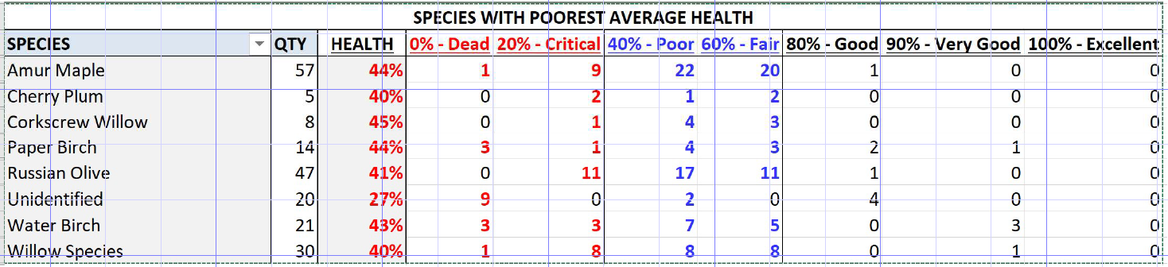

- We seem to have a lot of River Birches that are in generally good condition. They also drop a tremendous amount of organic matter into our ponds. Should we consider removing/replacing them?
  - As shown in the table below, approximately 19% of HOA-owned trees are Birches, the majority of which are River Birches. River Birches (as opposed to Paper Birches and Water Birches) are in generally good condition. The overall recommendation is to routinely inspect/prune our River Birches, and apply supplemental water if necessary. River Birches live approximately 100 years, provide beautiful shade and wildlife habitat, but need tremendous amounts of water (estimated at greater than 100 gallons/day during peak summer heat) and are prone to drought stress and aphid infestation (with the accompanying/annoying “honeydew” secretions.) Routine pruning will optimize canopy size and organic matter deposition, as well as reducing the chances of limb breakage due to snow/ice loading. When a River Birch does die, we should thoughtfully consider the location, and possibly choose an alternative long-lived species that is not such a water hog. We should also consider conifers at appropriate locations to minimize organic matter deposition.
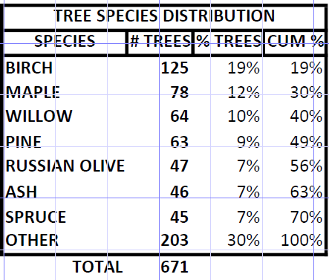
Ongoing Maintenance
- What are the plans for maintaining the water ways and riparian areas once the ponds are dredged and trees pruned/removed/replanted?
  - HOA member education regarding keeping organic matter and nutrients out of the waterways is paramount if any of the other suggested remediations are to be successful, both in the near- and long-term.

  - Tree maintenance (pruning) is key to reducing organic matter deposition in the near term. Tree selection for replants is critical in this regard over the long-term.
  - The project team plans on consulting with a local arborist to develop and organize a Riparian Management Plan by pond. The plan will outline specific management guidance such as tree and shrub care, and tree removal and replacement for our trees as they approach their life expectancy.
  - During the dredging process, catch basins could be installed to capture future sludge and debris in specific areas. These basins would be dredged or cleaned out periodically (every 1 or 2 years) versus dredging the entire waterway every ten years or so. See discussion for Dredging Question 7 above. The required water velocities to move organic matter sludge downstream to the catch basins would need to be proven by field tests.
  - A Waterway Management company, such as Eco Lake who we currently use, will continue to monitor and maintain water quality by applying algaecides and herbicides when needed during summer months. After dredging, we anticipate these maintenance applications will be less needed and should reduce the maintenance budget.
- Why is there so much less sludge to be removed from Pond #4, compared to the other ponds?

  - Pond #4 is the largest, and deepest pond and is fed exclusively from groundwater upwelling and supplemental groundwater pumping with a single water well. The absence of “ditch water” as a supply source, which may include high and varying levels of Nitrogen and Phosphate nutrients, may be instrumental in less algae and weed growth, resulting in less sludge deposition. Water sampling and testing will bear this out.

Costs / Budget

Q1: Is the $209,000 for the Pilot Project part of or in addition to, the $444,800 estimate for the HOA Waterway Maintenance?
A1: The $209K estimate (now updated to $240K) is for a comprehensive approach to the Pond #2 Pilot and cannot be directly compared with Golden Environmental’s May 2022 estimate of $444K for just the dredging work for Ponds #2 & #3.

Q2: Why is the HOA relying upon engineering assessments and cost estimates from 2007-2008, for a project that is proposed to be pursued in 2023-2025?
A2: The older assessments and costs estimates from the 2007-2008 time frame were included in the HOA’s outreach to Owners to provide context for the magnitude of the scope and cost of the project. For instance, the estimated volume of sludge to be removed increased 10-fold from 2007 to 2022. The outreach included recent 2022 assessments by SPF Engineering and Golden Environmental, which formed the basis for the Committee’s project proposal that was first presented to the Board in August 2022. No detailed cost estimates were performed at that time. At the request of the Board, the Committee performed detailed estimates, broken out by Project phase. The MC Board is currently reviewing those estimates.
Q3: When will the 2023 updated project scope and cost estimate be available?
A3: Before July 31, 2023 or as soon thereafter as possible.
Q4: It would be useful to have one document with all the estimated costs on it.

A4: Agreed. The Committee developed a Project Summary which will be shared after Board review. The Board is also currently reviewing the Committee’s estimated costs for each phase of the project.
Q5: Will the Project be partially, or fully, funded out of HOA reserves?
A5: No. The HOA currently does not have sufficient reserves to fund the Project. One or more Special Assessments will likely be required to fund the phase project, over several years.

CONTRACTORS
Q1: Who are SPF Engineering and Golden Environmental, and how do we know we can rely upon their engineering and cost estimates as the basis for our project?
A1: SPF Engineering (Now HDR) was hired by the Board in 2007 to conduct a feasibility study for a pressurized irrigation system, water rights and waterways maintenance plan. This study identified the dredging of priority areas within MC’s pond system as an option toward addressing the maintenance of the ponds. The suggestions from the study were not pursued at that time. In June of 2022, SPF was hired to develop a proposal for pond dredging options, costs, and qualified contractors to do the work. Golden Environmental was highly recommended by SPF, and provided MC with a Waterways cleanout proposal. Golden Environmental is known for its broad range of dredging, dewatering and material processing services, sludge and sediment removal from waterways and ponds, and trucking services, including large bulk tankers and vacuum trucks. For more information on Golden Environmental visit: http://www.golden-enviro.com/aboutus.html
Q2: Can the dredging contractor provide a list of projects like ours which have been seasoned for a reasonable period of 5-10 years so we can assess the long-term outcome? If not, then this is all just an experiment to see what kind of work the contractor can do, but the experiment is at the cost of the MCHOA. If we are going to have the contractor “demonstrate” their capabilities in an unproven environment like ours, good business practices would dictate that it be done at steep discount. Are we getting a large discount on this demonstration?
Q2 part 2: How will we go about pre-qualifying dredging contractors prior to going out to bid for the Pilot and other phases of the project?
A2: There are very few contractors in the Treasure Valley who have the skills and equipment to do large-scale mechanical and/or hydraulic removal of waterway sludge. References will be obtained from contractors selected by the Committee and approved by the Board for inclusion on any Requests for Proposals (RFPs) for the dredging work, which represents 55-60% of the project cost. The issue of cost certainty, discounts, and risk allocation (see recent pool replastering project) will be addressed in any Request For Proposals (RFPs) issued by MC to qualified contractors.
Other
Q1: Where will the access be to get to the water and haul out the sludge?

A1: See below Map of proposed Material Handling Sites prepared by SPF Engineering.

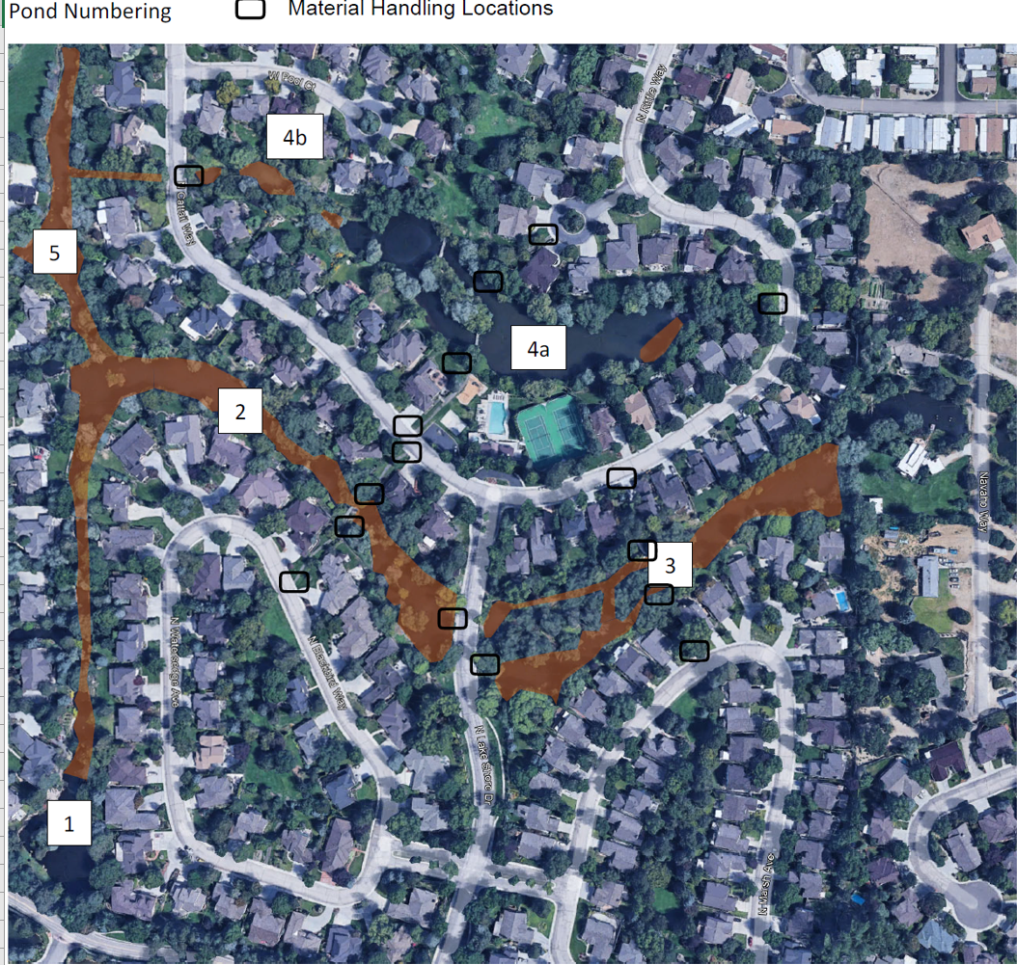

Q2: Will any damage to common or homeowners property be repaired by HOA?

A2: Yes, by the HOA or by the Project contractor(s) depending upon contract terms. Surveying of the property corners and pond boundaries should help minimize any avoidable property damage.

Q3: How long will the sludge piles sit around before being hauled away?

A3: For Phase 1 and Phase 2, which will use mechanical dredging, the sludge will not be piled/stored but hauled off for disposal. For Phase 3, hydraulic dredging will likely require the use of geo-tubes for dewatering the sludge prior to haul-off. Large surface areas are required for geo-tubes, so the most likely staging areas will be our HOA greenbelts (common areas) in close proximity to the ponds.

Q4: If the project is approved, where will sludge piles be located if not on the roads?

A4: See response to Q3 above.

